Bringing in the May 2024 - Vendor Information
- Festival is May 18-19 2024 from 12 Noon-6 PM (hours subject to change). Vendors will be located in Berkeley Springs State Park, which is in the middle of our little town of Berkeley Springs.
- The Festival is a juried show rather than “first come, first served”. Previous vendors have priority but you must apply! Vendors will be juried according to the following criteria:
  - Quality
  - Appropriateness for a Fairie Festival
  - Uniqueness of product within category
  - All items should be made by you, or be “unique collectibles” (ie, no plastic junk, please!) Vendors that provide a service (ie face painting, henna…) are also juried. To keep a level of quality and value we reserve the right to exclude items perceived to be of questionable value.
- Applicants must provide all elements to create their booth Space including tables, chairs, canopies, etc. Bringing in the May supplies the physical space only.
- A website where we can view your product is highly preferable to sending photos. Not only is this easier for us, we can link to it from our website once you’re accepted. Also, the website will tell us a bit more about you!
- All vendors must have a WV Business License NO EXCEPTIONS. Upon acceptance, we will send instructions for obtaining one if you need one. WV Business licenses are $30 and have no expiration date. We will purchase your Town of Bath business license for you, but you must have the WV Business License first!
- Vendors must have liability insurance. Most professional vendors already have this, but if you need it, policies are available online for as little as $50/event. Check out https://www.actinsurance.com/
- Vendor is responsible for setting up their booth in the provided timeline and is responsible for leaving their area litter free and in the same condition as when they arrived. We encourage you to use green products for bagging/wrapping etc.
- There is no electricity provided or available. There is decent cell service for most carriers.
- Booth set up is Friday, May 17 from noon until dark. Those setting up on Saturday must do so, and have their vehicle moved, by no later than 9:00 am
- Vendors are responsible for securing their booths for the overnight and off festival times.
- Booths cannot be dismantled until closing on Sunday unless prior approval is arranged with the Festival Committee.
- The 2024 vendor fee is
  - $175 for a Standard 10x10.
  - $225 for 10x20
We may be able to accommodate larger/unusual shaped booths at additional cost.
Instructions for payment will be sent upon your acceptance.
- Weapons and illegal drug paraphernalia are prohibited. We also encourage vendors to keep in mind that this a family event, so please keep your products “PG.” In order to be as inclusive as possible, please refrain from bringing any overtly religious items. Thank you!
- Wear a costume and decorate your tent appropriately. Be a part of the fun!
- Vendor applications will be open until February 15. Acceptances will be emailed by April 15.
PLEASE MAKE SURE YOUR EMAIL IS CORRECTLY TYPED! Email is the ONLY way we will convey your vending status. “Not getting the email” is not an excuse.
Bringing in the May and/or its sponsors are not responsible for loss, damage, theft, or acts of nature. Signing of the vendor application serves as confirmation of vendors agreement to these terms.
Vendors not adhering to these rules will be asked to leave and will forfeit all vendor fees.
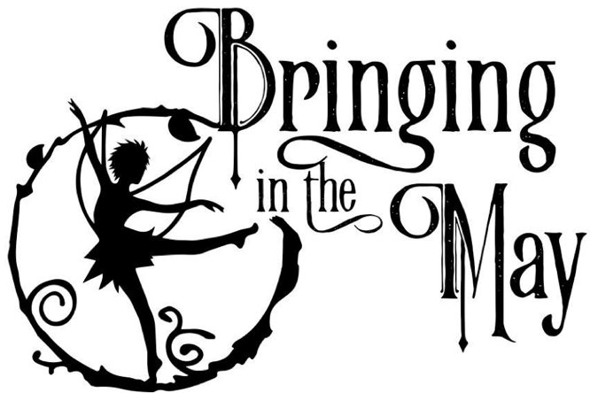

Vendor Application

Please read the Vendor Information before applying. Thank you!
Name of Vendor:
Contact name:
Doing Business as (Optional) :
Email:
Address:
City:
State, Zip
Website: (Highly recommended!)
Phone (cell preferred) _______________________________ May we send you texts?
WV Business License#
Please list your product(s).
Only products you list here will be permitted for sale in your booth.

Price point (min-max):
Would you like to demonstrate your art/craft?
Please consider it; we’d like as much audience engagement as possible. Yes No

